A PHARMACOVIGILANCE SELECTION OF LEVOTHYROXINE DRUG IN TREATMENT OF HYPOTHYRODISM
Report Submitted To
THE FACULTY OF PHARMACEUTICAL SCIENCES
DR.BABASAHEB AMBEDKAR TECHNOLOGY UNIVERSITY, RAIGAD

Mr. VEDANT SANTOSH WAGHULE
PRN Number: 2169271823024
Final Year B. Pharmacy (Semester – VII)
Academic Year 2024-2025
In partial fulfillment of the Requirement for Practice School
Under the domain of Pharmacovigilance
For the degree of
Bachelors of Pharmacy
Under the Guidance of
Mr. Kiran H. Bibave
(Assistant Professor of Pharmacology)

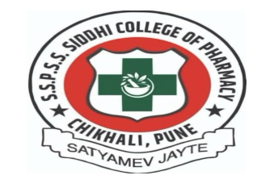
S.S.P Shikshan Sanstha's Siddhi College of Pharmacy, Chikhali, Pune- 411062 (2024-2025)

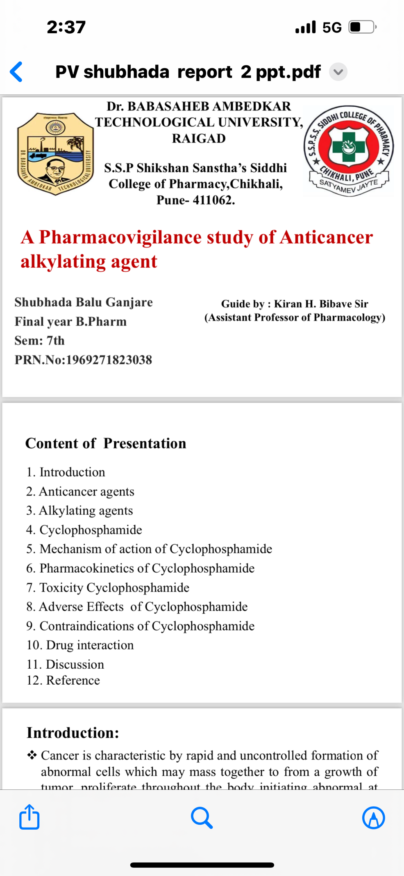
Dr.BABASAHEB AMBEDKAR TECHNOLOGICAL UNIVERSITY, RAIGAD

DECLARATION BY THE STUDENT

I,Mr. Vedant Santosh Waghule declare that the report entitled " A PHARMACOVIGILANCE SELECTION OF LEVOTHYROXINE DRUG IN TREATMENT OF HYPOTHYRODISM" submitted by me for Practice School under the domain of Pharmacovigilance is the record of work carried out by me under the guidance of Mr. Kiran H. Bibave and has not formed the basis for the award of any degree or diploma or other titles in this or any other University.

Date: Name and Signature of the student
Place: Chikhali

S.S.P Shikshan Sanstha's Siddhi College of Pharmacy,
Chikhali, Pune-411062

CERTIFICATE BY THE GUIDE

This is to certify that the report entitled, " A PHARMACOVIGILANCE SELECTION OF LEVOTHYROXINE DRUG IN TREATMENT OF HYPOTHYRODISM " submitted for Practice School under the domain of Pharmacovigilance is the record of research work carried out by Mr. Vedant Santosh Waghule under my guidance and supervision and that this has not formed the basis for the award of any degree or diploma or other titles in this or any other University.

Date: Name and signature of Guide
Place: Chikhali

S.S.P Shikshan Santha’s, Siddhi College of Pharmacy
Chikhali, Pune- 411062

ENDORSEMENT BY THE HOD

This is to certify that the report entitled " A PHARMACOVIGILANCE SELECTION OF LEVOTHYROXINE DRUG IN TREATMENT OF HYPOTHYRODISM " is a record bonafide research work carried out by Ms. Mr. Vedant Santosh Waghule under my guidance at S.S.P Shikshan Sanstha's Siddhi College of Pharmacy, Chikhali, Pune-411062

Date: Name and Signature
Place: Chikhali
S.S.P Shikshan Sanstha's Siddhi College of Pharmacy,
Chikhali, Pune-411062

ENDORSEMENT BY THE PRINCIPAL
This is to certify that the partial research work for the report entitled " A PHARMACOVIGILANCE SELECTION OF LEVOTHYROXINE DRUG IN TREATMENT OF HYPOTHYRODISM’’ is a record of bonafide research work carried out by Mr. Vedant Santosh Waghule under my guidance at SSP Shikshan Sanstha's Siddhi Collage of Pharmacy, Newale Vasti, Chikhali, Pune-411062.

Date:
Place: Chikhali Dr. P. N. Sable.
Principal
Acknowledgement
It gives me immense pleasure to acknowledge everyone who has supported and helped me during the course of my practice school report. I express my deepest sense of gratitude from the bottom of my heart to my respected and beloved guide Mr. Kiran H. Bibave Assistant Professor, department of pharmacology, Siddhi College of Pharmacy, Chikhali for his excellent guidance, critical supervision, and a keen interest, and continuous encouragement throughout the study. His active guidance helped me to develop skills and insight in research and scientific presentation. I would like to express my profound gratitude and sincere and respectful thanks to Dr. P.N. Sable Principal, Siddhi College of pharmacy, Chikhali, for giving great guidance in research as well as moral support like further during critical conditions.
It is indeed a difficult task to acknowledge the service of all those gentle people who have extended their valuable suggestions and support directly or indirectly whose names have been unable to mention. Besides this, I am thankful to all those who have knowingly and unknowingly helped me in the successful completion of this report.

Mr. Vedant Santosh Waghule

